**Digital Logic Design (DLD)**

**(Lab Task No 5)**



Session (2022-2026)

Program

**BS-Computer Science**

Submitted By:

Student Name: Shaheer Ali Roll Number: 301-221044

Supervised By:

Ms. Muneeba Darwaish

Lecturer

CS& IT Department

**Hazara University, Mansehra**

**EXPERIMENT 05:**

**Implementation of a 4 to 1 MUX using Gates and using IC 74LS153.**

**Objective:**

To familiarize student with basic working of multiplexer and implementation of 4x1 mux.

**Equipment / Tool:**

Trainer, IC 74LS04 (NOT), 74LS32 (OR), 74LS08 (AND), 74LS153 (4 TO 1 MUX).

**Background Theory:**

A MUX is a combinational circuit that can be used to select data and produce it at the output. They can be 2 to 1, 4 to 1, 8 to 1, 16 to 1, etc. It has a lot of applications. There are many scenarios in which we have to select a particular data and produce it at the output.

**Lab Tasks:**

* Write the truth table for a 2 to 1 MUX, design a circuit from it, implement it and verify the results.
* Write down the truth table for a 4 to 1 MUX, draw the circuit, implement it and verify the results.
* Use the IC 74LS153 (4 to 1 MUX) and verify the results.

**Procedure**

Following is the circuit for 2 to 1 MUX and truth table:

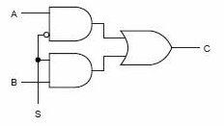

|  |  |  |  |  |
| --- | --- | --- | --- | --- |
| **S** | **B** | **A** | **Y** | **Proof** |
| 0 | X | 0 | 0 |  |
| 0 | X | 1 | 1 |  |
| 1 | 0 | X | 0 |  |
| 1 | 1 | X | 1 |  |

**Circuit Diagrams:**

Draw the diagram of 4 to 1 MUX as follow

Fill in the following Truth Table:

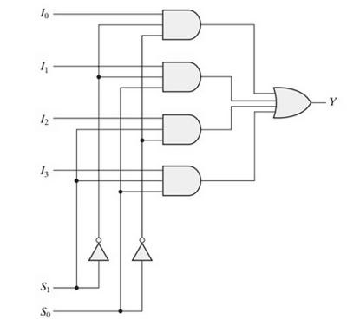

|  |  |  |  |  |  |  |  |
| --- | --- | --- | --- | --- | --- | --- | --- |
| **S1** | **S0** | **L3** | **L2** | **L1** | **L0** | **Y** | **Proof With**  **Circuit Diagram** |
| 0 | 0 | X | X | X | 0 | 0 |  |
| 0 | 0 | X | X | X | 1 | 1 |  |
| 0 | 1 | X | X | 0 | X | 0 |  |
| 0 | 1 | X | X | 1 | X | 1 |  |
| 1 | 0 | X | 0 | X | X | 0 |  |
| 1 | 0 | X | 1 | X | X | 1 |  |
| 1 | 1 | 0 | X | X | X | 0 |  |
| 1 | 1 | 1 | X | X | X | 1 |  |

**Implementing using 74LS153:**

Following is the pin configuration extracted from the datasheet. DUAL-IN-LINE Package

**Function Table:**

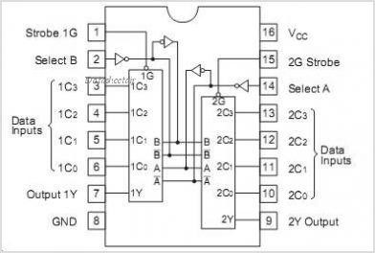

|  |  |  |  |  |  |  |  |  |
| --- | --- | --- | --- | --- | --- | --- | --- | --- |
| **Select Inputs** | |  | **Data Inputs** | | | **Strobe** | **Output** | **Proof With**  **Circuit Diagram** |
| **B** | **A** | **C0** | **C1** | **C2** | **C3** | **G (E)** | **Y** |  |
| X | X | X | X | X | X | H | L |  |
| L | L | L | X | X | X | L | L |  |
| L | L | H | X | X | X | L | H |  |
| L | H | X | L | X | X | L | L |  |
| L | H | X | H | X | X | L | H |  |
| H | L | X | X | L | X | L | L |  |
| H | L | X | X | H | X | L | H |  |
| H | H | X | X | X | L | L | L |  |
| H | H | X | X | X | H | L | H |  |